02.19.2021 |  | Status Report
Snapshot of Project or Task:
Activity | Percent Complete | Issues  Configuration, Testing, Validation, Troubleshooting
Create a network diagram | 100% | Configuration: Diagram of current state of Hyper V environment.
Version Control | 100% | Configuration: Version control with GitHub
Status Summary: Discuss how you addressed configuration, testing, validation and troubleshooting
The Hyper V network consists of two servers and one client. A Domain Controller has been assigned the roles Active Directory and DNS. Another Server has been assigned the roles DHCP and DNS which provides the client machines with IP addresses. Currently there is only one client machine loaded with Windows 10. See Figure 1-1 on page 2.

Submitted By:
James Mayfield

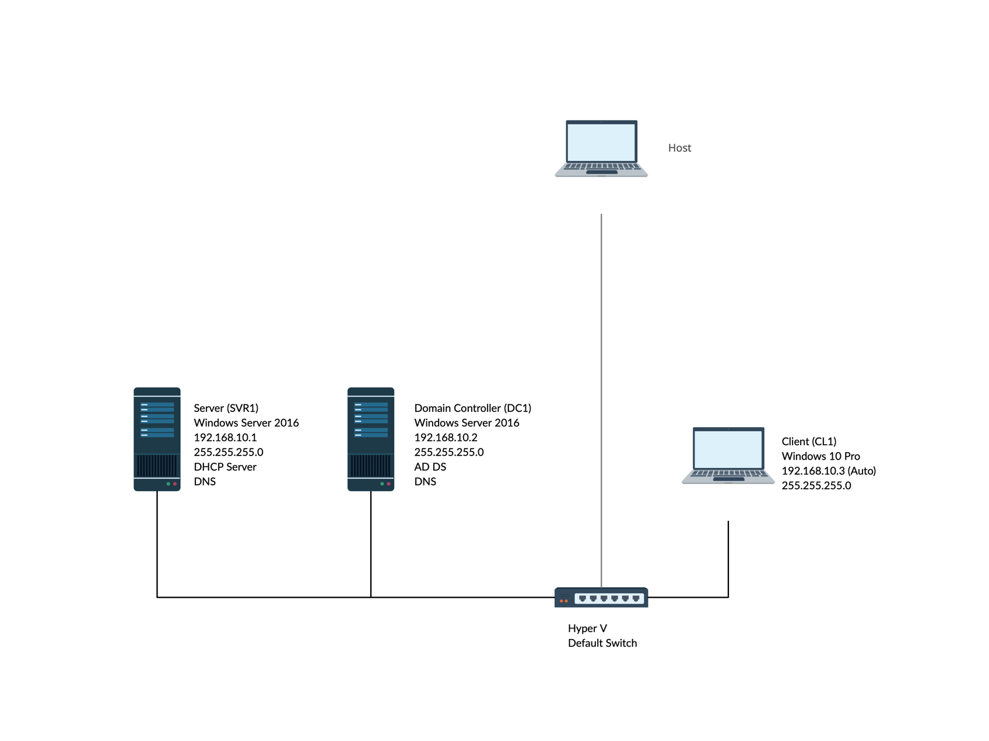
Figure 1-1

